**Information System Management Lab**

**BCOM 307**

**Assignment #22**

***Submitted by:***

**Name:** YASH JAIN

**Enrollment No:** 03914788818

**Semester:** B.Com(H) 5th Semester

**Class:** B.COM(H)

**Section:** B.Com 5A

**Date of Submission:** 29/10/2021

***Submitted to:***

**Praveen Kumar Singh**

**Assistant Professor, MAIMS**



**Department of Commerce**

**Maharaja Agrasen Institute of Management Studies**

**Affiliated to Guru Gobind Singh Indraprastha University, Delhi**

**Sector -22, Rohini, Delhi -110086, India; www.maims.ac.in**

Maharaja Agrasen Institute of Management Studies

Affiliated to GGS IP University; Recognized u/s 2(f) of UGC Recognized by Bar Council ofIndia; ISO 9001: 2015

Certified Institution Sector 22, Rohini, Delhi -110086, India; [www.maims.ac.in](http://www.maims.ac.in/)

Department of Commerce

Academic Year: 2020-21

Semester: Vth

# Assignment No. 22

# Unit No:

**Course/Subject Code:** BCOM 307 **Subject Title: Information System Management Lab**

# Issue Date Last Date of Submission:

**Instructions for Students:**

# All Questions are Compulsory.

1. The student should attach proper cover page for each assignment clearly mentioning the Assignment No.
2. Each assignment should be prepared by the student individually with proper explaination and screenshots.
3. A4 size ruled sheets should be used for the assignment.
4. Assignment pages should be serially numbered at the bottom of page.

***During online education mode, upload scanned copy of the complete assignment including cover page latest by due date.***

|  |  |  |
| --- | --- | --- |
| **Question No.** | **Question** | **CO No.** |
| 1 | Display the number of employees in each department with their department names. | **CO2, CO3, CO4, CO5** |
| 2 | Display the employee name whose location is same as department location. |
| 3 | Display the department name where number of employees is more than 2. |
| 4 | Display the employee name whose name starts with 's' and whose salary is more than 1000. |
| 5 | Display the maximum, minimum, and average salary of employees table. |

**ASSIGNMENT 22 - INNER JOIN CLAUSE**

**Task 1 : Display the number of employees in each department with their department names.**

This task can be completed using the **SQL INNER JOIN Clause** used with the **GROUP BY** Clause.

The **JOIN** Statement in SQL is used to combine two or more tables in the result set of a database, on the basis of a relation between columns of the tables. **INNER Join** returns all rows from both tables where there is a match. The syntax for this is -

SELECT column1, column2 from <table1> INNER JOIN <table2> ON table1.common_column=table2.common_column;

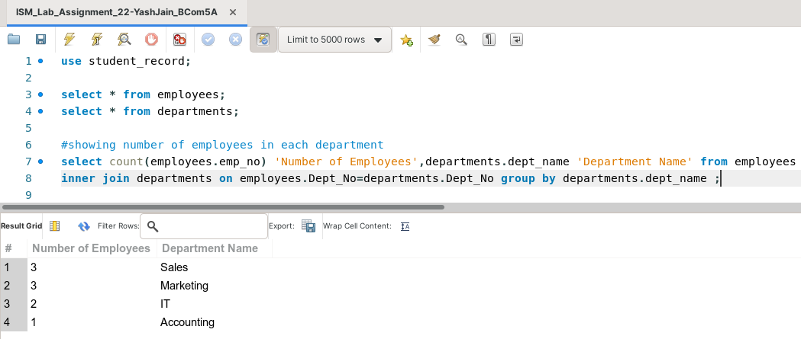

**Task 2: Display the employee name whose location is same as department location.**

This task can be completed using the **SQL INNER JOIN Clause.**

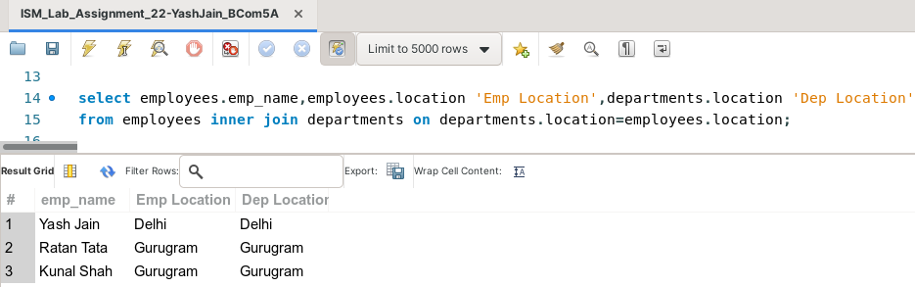

**Task 3: Display the department name where number of employees is more than 2.**

This task can be completed using the **SQL INNER JOIN Clause** used with the **GROUP BY** Clause, the **HAVING** Clause and the **COUNT( )** Aggregate Function.

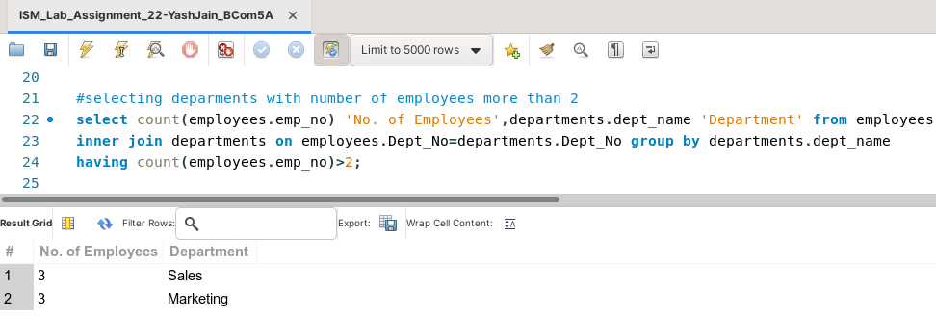

**Task 4: Display the employee name whose name starts with 's' and whose salary is more than 1000.**

This task can be completed using the **SQL INNER JOIN Clause** used with the **LIKE** Predicate, and the **AND** operator.

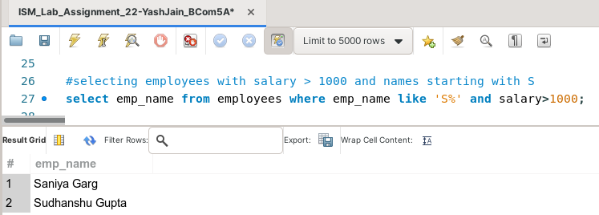

**Task 5: Display the maximum, minimum, and average salary of employees table.**

This task can be completed using the **AVG( ), MIN( )** and **MAX( )** Aggregate Functions.

